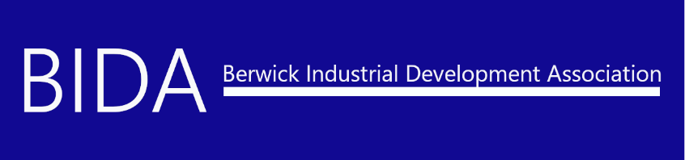
SMALL/LARGE COMMUNITY ROOM RENTAL POLICY & REGULATIONS

B.I.D.A. is aware of the need for meeting space for local groups. Making available such accommodations to the public is an additional service, which B.I.D.A. may render under conditions set by the B.I.D.A. Board of Directors. Permission to use the meeting room does not constitute an endorsement of a group’s policies or beliefs.
Space, staff limitations, and B.I.D.A. schedules necessarily require regulatory measures, which affect the use of the meeting room. These rules may be modified for official B.I.D.A. functions when deemed appropriate. The B.I.D.A. Board and Executive Director reserve the right to deny permission to use the meeting rooms.
______________________________________________________________________________RESERVATIONS:
Community groups interested in booking the small and/or large community room(s) need to fill out a community room application. Please submit your application through one of the following options:
- In person at our office between the hours of 9AM – 3PM, Monday – Friday (Hours may vary for holidays).
- Download and fill out our online PDF form and email or fax back to the Business Office, Attn: Amy Shortlidge at ashortlidge@bida.com or 570-752-2334.
- You may also mail your completed application to: B.I.D.A. 107 South Market Street, Suite 5, Berwick, PA 18603 - Attn: Amy Shortlidge
_____________________________________________________________________________ PERMISSIBLE MEETINGS:
Priority for use of the small/large community room(s) will be given in the following order:
- B.I.D.A. sponsored meetings or programs/events.
- Non-profit organizations sponsored meetings or programs/events.
- Organizations engaged in educational, cultural, intellectual, civic, or charitable activities.
- Other meetings or programs/events, as requested and approved by the B.I.D.A. Executive Director and/or Board of Directors.
COMMUNITY ROOM RENTAL FEE SCHEDULE

BUSINESS HOURS: 8AM – 5PM
Non-Profit Large Community Room: $75 Full Day $35 Half Day
Small Community Room: $50 Full Day $25 Half Day

For-Profit Large Community Room: $150 Full Day $80 Half Day
Small Community Room: $100 Full Day $50 Half Day

AFTER BUSINESS HOURS: 5PM - 10PM
Non-Profit Large Community Room: $75
Small Community Room: $50

For-Profit Large Community Room: $150
Small Community Room: $125
***These fees do NOT include trash removal or returning the room to its original set-up. An additional $50 will be added if B.I.D.A. staff must remove trash, clean-up and rearrange the room.
EXTRA SERVICES AVAILABLE:
- Refreshments – Soft Drinks/Bottled Waters $1/bottle
- AV/Media Projector Use $50 Security Deposit
- AV/Media Support Personnel $45/hour
- Paper Products (Plates/Napkins/Cups/Utensils) $20/flat rate
- Full Kitchen Use $50/flat rate

COMMUNITY ROOM RENTAL APPLICATION

Date of Application: ______________ Date Received by B.I.D.A.: _____________________
Name of Organization/Business:
Non-Profit: For Profit:
Name of Contact: _____________________________________________________________________
Organization/Business Name: ___________________________________________________________
Organization/Business Address: __________________________________________________________
____________________________________________________________________________________
Organization/Business Phone: ___________________________________________________________
Contact Email Address: _________________________________________________________________
Contact Cell Number: __________________________________________________________________
Purpose for Community Room Rental: ____________________________________________________
_____________________________________________________________________________________
Anticipated # of Guests: ____________ Use of AV/Media Projector: Yes / No
Need AV/Media Support Staff: Yes / No Conference Calling: Yes / No
Use of Full Kitchen (w/ the Large Community Room Rental ONLY): Yes / No
Date of Meeting: ______________________________________________________________________
Start Time: ________________________________ End Time: _________________________________
Small Conference Room Needed: Large Conference Room Needed:

***See reverse side to sign contract – please sign and return to B.I.D.A. Administration to process.***

I, the undersigned, do hereby acknowledge that prior to use of the Small and/or Large Community Room(s), we will have read and reviewed B.I.D.A.’s Community Room Use Policy and Regulations. We, individually and on behalf of the Organization/Business, agree to abide by all such policies, rules and regulations regarding our use of the room. Further, the Organization/Business will undertake its best efforts to cause all others in the room during our use thereof to abide by the polices, rules and regulations.
We, do hereby further agree to indemnify and hold harmless the B.I.D.A. Board of Directors and Staff from any and all claims, demands, causes of action and any and all other expense, including attorney’s fees, should any be incurred arising from or during the course of our use of the room pursuant to this APPLICATION.
We shall also be responsible for any and all damages that may be caused to B.I.D.A.’s facilities, equipment, and other personal property, whether said damage is negligently or willfully caused as a result of our use of the Small and/or Large Community Room(s).
Room rental fees must be paid in full at the time of application (pending the availability of dates). Additional services, such as refreshments, AV/media projector, full kitchen usage will be billed immediately following the event. Payment is expected within fifteen (15) days of billing date.

I, ___________________________________________________________________, as the
(PRINT NAME)
appropriate contact person for ____________________________________________________ agree
(ORGANIZATION/BUSINESS NAME)
that our group will abide by the rules slated in the Community Room Rental Policy of B.I.D.A.

Signature: ____________________________________________ Date: _________________________
*************************************************************************************OFFICIAL USE BELOW
Room Fee $___________
Kitchen Usage $___________
AV/Media Projector Usage $___________
AV/Media Support Personnel # of hours ____________ x $45/per hour $___________
Refreshments # of drinks _____________ x $1/per drink $___________

